Psychology 301 Cognitive Neuroscience Fall 2023

Course Objectives:
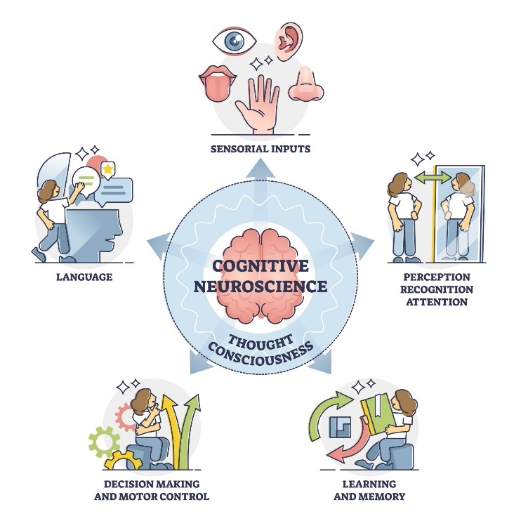
The goal of this course is to introduce ideas of how human behavior is linked with what is happening in the brain. Cognitive neuroscience continues to be a “hot” field and there is much enthusiasm about the applications of this research. This is evidenced by the regularity with which articles appear on this topic in the popular press. For example, Pixar released “Inside Out”, set inside the brain of a teenage girl. Reporting in the neurosciences is particularly prone to sensationalism and misinformation (Illes, 2010). Understanding the intricacies of cognitive neuroscience will help you to evaluate claims made by the media and policymakers concerning the applications of this kind of research. Can we detect if someone is lying using fMRI? Should students learning math be banned from using calculators in class because their frontal lobes are not active when they do so? These questions are of interest to society at large because they have implications for criminology, education, advertising, etc… After completing this course, you will have a basic understanding of neuroscientific methods, the anatomy of the brain, and how the brain gives rise to cognition, action, and emotion. This knowledge will help you to interpret for yourself how this research should be used and to what extent these findings are applicable to more wide-ranging issues.

Course information:

Class time: MW 10:20-11:40

Room 118, Psychology Building

Instructor:
Susan Ravizza
432-3366
ravizzas@msu.edu
Office hours: W 2-3 and by appointment through Zoom or in person

Teaching Assistant:
Jodie Yen
yenjodie@msu.edu
Office hours: Th 11:30-1:30 through Zoom
Zoom link: https://msu.zoom.us/j/6966925916

Required reading:
Scientific articles (links posted on D2L)

Recommended reading:
MS Gazzaniga, RB Ivry, GR Mangun. “Cognitive Neuroscience: The Biology of the Mind” 5th Edition (2019)

Course grading:

IN PERSON Exams (3 x 25%) 75%
Blog Entry/Tweet/FB post 15%
D2L Quizzes (best 8 of 11) 10%

Exams:
There will be three exams. Each exam will be open-note and composed of multiple choice and essay questions. All exams will be held in our regular classroom.

Blog Entry/Tweet/FB post
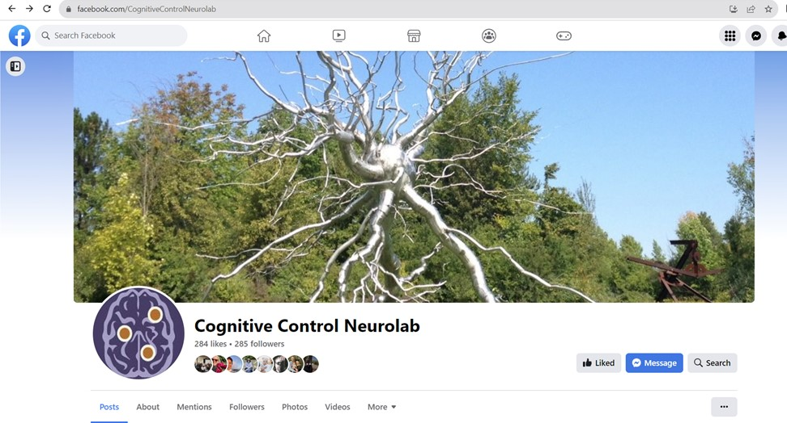
One of my educational goals is to use social media to inform the general public about cognitive neuroscience research. I post content about my research through my lab blog (ravizzalab.wordpress.com), Facebook page (Cognitive Control Neurolab) and twitter account (ravizzalab). Every week, 7-8 students (chosen randomly) will write a blog entry about a recent finding in cognitive neuroscience that describes the finding and gives the student’s opinion. The finding must be something reported in the press which you can find by searching Science Daily, Google News, or other news outlets. The reported finding must
- be in cognitive neuroscience. Therefore, it must tell us something about how people use their brains to think or behave. Clinical studies of what causes a disease (for example, Alzheimer's) are not appropriate because it doesn't explain how people with the disease think. A study showing the kinds of thinking or movement problems associated with a disease are appropriate. If you have any doubts if your topic is appropriate, feel free to ask either me or the TA.
- describe the results of an experiment and not just the reporter's opinion.
- be in the press in the last 3 weeks
- be associated with a link

Blog entries should be relatively informal and written in lay language that could be easily understood by someone with no background in cognitive neuroscience. Of course, grammar and spelling need to be correct. Blog entries should be about 500 words. The blog entry should describe the finding and why YOU think it is important or not important. It’s best to start this section with “I think this study is important because…” and then elaborate.

At the bottom of the blog, you should write a post that could be used on Facebook and Twitter. You are NOT required to post them yourselves on your personal feeds. Instead, we will pick the best of the bunch each week and post the blog, FB post, and tweet on the Internet (anonymously if the winner prefers).

The list of due dates will be posted on D2L and the first blog will be due Friday, September 15. Blog entries should be uploaded to D2L in the appropriate dropbox. Late blogs will be penalized 1 point for every day they are late. Please put your due date in your calendar - you will receive no reminders about when it is due!

Points for the blog, tweet, and post are determined in the following manner:

Appropriate topic 2 pts.
Finding is clearly described 4 pts.
Your opinion on why the finding is important or not 4 pts.
Link to media article is provided 1 pt.
Facebook post/Tweet 2 pts.
Spelling/Grammar 2 pts.
TOTAL 15

D2L Quizzes
All quizzes will be held via D2L and thus the course requires access to high-speed internet. You will have one week to complete each quiz. Quizzes are open book.

Extra credit
If you would like to obtain extra credit, you can comment on the blogs posted on ravizzalab.wordpress.com. You can make up to two comments – each worth 1% of your grade. The comments should be on two different blogs. Comments should be substantive and not just say “nice job”. Comments also need to be polite! Your comment will not show up immediately on the blog because I have to approve it. All comments need to be made by December 8 to receive credit.

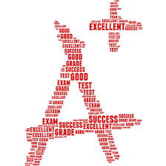
Grading scale:
90% and above = 4.0
85% - 89.9% = 3.5
80% - 84.9% = 3.0
75% - 79.9% = 2.5
70% - 74.9% = 2.0
65% - 69.9% = 1.5
60% - 64.9% = 1.0
59.9% and below = 0.0

Emergencies and Schedule Conflicts:
You may take a makeup exam in case of: 1) a documented medical emergency, or 2) a schedule conflict that you know about in advance such as a religious holiday or sports travel. In either case, please send email identifying the reason for missing the exam ASAP. In case of a schedule conflict, you must send this email at least a week in advance of exam day. Do not assume I have gotten your email unless I have responded to you.

In either case, you may take the exam either at a different time on the exam day or the day after. If you cannot take the exam on one of those two days, then that exam will be omitted from your final score and its points distributed over the other exams. If you miss an exam for any other reason or don’t notify me about your emergency or conflict, your score will be 0.

Class schedule

Lecture | Date | Topic | Quiz Due | Readings
1 | 8/28/2023 | What is cognitive neuroscience and what isn’t it?
2 | 8/30/2023 | Why do we need to know about neurons? |  | #1 Father of Modern Neuroscience
 | 9/4/2023 | Labor day Holiday
3 | 9/6/2023 | How can we know what the brain is doing? | 1
4 | 9/11/2023 | How can we know what the brain is doing? |  | #2 How the mind emerges from the brain’s complex network
5 | 9/13/2023 | What is a perceptual hierarchy? | 2
6 | 9/18/2023 | What is a distributed object representation?
7 | 9/20/2023 | Are faces processed uniquely? | 3 | #3 How the brain reads faces
 | 9/25/2023 | Catch up/Review session
 | 9/27/2023 | Exam 1 – In-class
8 | 10/2/2023 | How does the brain enhance perception of attended information? |  | #4 The brain-boosting power of video games
9 | 10/4/2023 | Is unattended information represented in the brain? | 4
10 | 10/9/2023 | Is movement a cognitive process? |  | #5 How the brain constructs the outside world
11 | 10/11/2023 | How does the brain make it possible to play tennis or volleyball? | 5
12 | 10/16/2023 | Why are we talking so much about movement?!?$%!
13 | 10/18/2023 | How do our brains store so much information? | 6 | #6 The brain learns in unexpected ways
 | 10/23/2023 | Fall Break
14 | 10/25/2023 | Why do amnesiacs remember how to write? | 7
 | 10/30/2023 | Catch up/Review session
 | 11/1/2023 | Exam 2 – In-class
15 | 11/6/2023 | Why are language disorders so common? |  | #7 How brains seamlessly switch between languages
16 | 11/8/2023 | How does the brain allow people to communicate? | 8
17 | 11/13/2023 | Is there some truth to being a left-brained person?
18 | 11/15/2023 | Why do I forget the reason I stood up? | 9
19 | 11/20/2023 | How does your brain enable you to sit in class instead of sleeping in? |  | #8 Is only child syndrome real?
 | 11/22/2023 | Class cancelled
20 | 11/27/2023 | Why do I cry at a sad movie? | 10 | #9 On the nature of fear
21 | 11/29/2023 | Why don’t I Hulk out all the time? |  | #10 Brain waves sychronize when people interact
 | 12/4/2023 | Catch up/Review session | 11
 | 12/6/2023 | Exam 3 – In-person
 | 12/15/2023 | Final exam time (7:45-9:45am)

Accommodations for Students with Disabilities:
From the Resource Center for Persons with Disabilities (RCPD): Michigan State University is committed to providing equal opportunity for participation in all programs, services and activities. Requests for accommodations by persons with disabilities may be made by contacting the Resource Center for Persons with Disabilities at 517-884-RCPD or on the web at rcpd.msu.edu. Once your eligibility for an accommodation has been determined, you will be issued a Verified Individual Services Accommodation ("VISA") form. Please present this form to me at the start of the term and/or two weeks prior to the accommodation date (test, project, etc.). Requests received after this date will be honored whenever possible.

Academic Honesty:
Article 2.III.B.2 of the Academic Rights and Responsibilities states that "The student shares with the faculty the responsibility for maintaining the integrity of scholarship, grades, and professional standards." In addition, the [insert name of unit offering course] adheres to the policies on academic honesty as specified in General Student Regulations 1.0, Protection of Scholarship and Grades; the all-University Policy on Integrity of Scholarship and Grades; and Ordinance 17.00, Examinations. See Spartan Life Online (splife.studentlife.msu.edu) and/or the MSU Web site (msu.edu) for more.
Therefore, unless authorized by your instructor, you are expected to complete all course assignments, including homework, lab work, quizzes, tests and exams, without assistance from any source. You are expected to develop original work for this course; therefore, you may not submit course work you completed for another course to satisfy the requirements for this course. Also, you are not authorized to use the www.allmsu.com Web site or generative artificial intelligence (AI) to complete any course work in this course. Students who violate MSU academic integrity rules may receive a penalty grade, including a failing grade on the assignment or in the course, and . Contact your instructor if you are unsure about the appropriateness of your course work. (See also the Academic Integrity webpage.)

Limits to Confidentiality:
Essays, journals, and other materials submitted for this class are generally considered confidential pursuant to the University's student record policies. However, students should be aware that University employees, including instructors, may not be able to maintain confidentiality when it conflicts with their responsibility to report certain issues to protect the health and safety of MSU community members and others. As the instructor, I must report the following information to other University offices (including the Department of Police and Public Safety) if you share it with me:
- Suspected child abuse/neglect, even if this maltreatment happened when you were a child,
- Allegations of sexual assault or sexual harassment when they involve MSU students, faculty, or staff, and
- Credible threats of harm to oneself or to others.
These reports may trigger contact from a campus official who will want to talk with you about the incident that you have shared. In almost all cases, it will be your decision whether you wish to speak with that individual. If you would like to talk about these events in a more confidential setting you are encouraged to make an appointment with the MSU Counseling Center.

Disruptive Behavior:
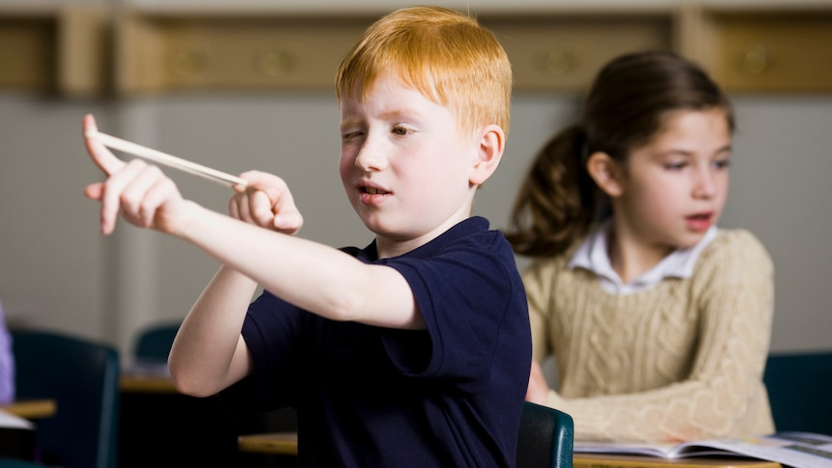
Article 2.III.B.4 of Student Rights and Responsibilities for students at Michigan State University states: "The student's behavior in the classroom shall be conducive to the teaching and learning process for all concerned." Article 2.III.B.10 states that "The student and the faculty share the responsibility for maintaining professional relationships based on mutual trust and civility." General Student Regulation 5.02 states: "No student shall . . . obstruct, disrupt, or interfere with the functions, services, or directives of the University, its offices, or its employees (e.g., classes, social, cultural, and athletic events, computing services, registration, housing and food services, governance meetings, and hearings).” Students whose conduct adversely affects the learning environment may be subject to disciplinary action through the Student Judicial Affairs office.

